WordPress Theme Development
- WordPress Theme Customization simply basic part
- WordPress Theme Customization full part
If you want to full height in anyone tag, you use css properties height:100vh;

WordPress Theme Customization simply basic part:-

- Xampp Software open $→$ Apache & MySql (start)
- Explorer $→$ htdocs $→$ WordPress file $→$ wp-content $→$ themes
- Create a new theme folder $→$ index.php & style.css file create
- Now, style.css open for create the theme details above below:
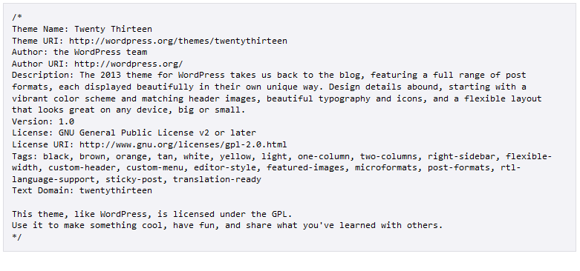
- Then save and load your location in a browser. You will look that your brower have no content.
- So, you open index.php and write something. Save and refresh and look change.
- Now, you open index.php file and write HTML5 basic code.
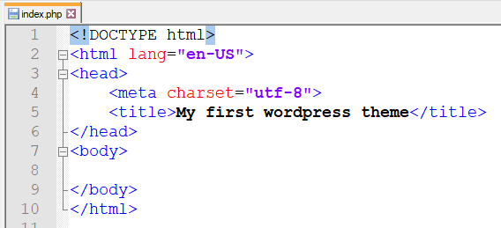

- Then you write some code like as below:-
<!DOCTYPE html>
<html <?php language_attributes(); ?>>
<head>
<meta charset="<?php bloginfo('charset'); ?>">
<title><?php bloginfo('name'); ?> | <?php bloginfo('description'); ?></title>
</head>
<body <?php body_class(); ?>>

<h1><a href="<?php echo home_url(); ?>"><?php bloginfo('name'); ?></a></h1>
<h3><?php bloginfo('description'); ?></h3>

</body>
</html>
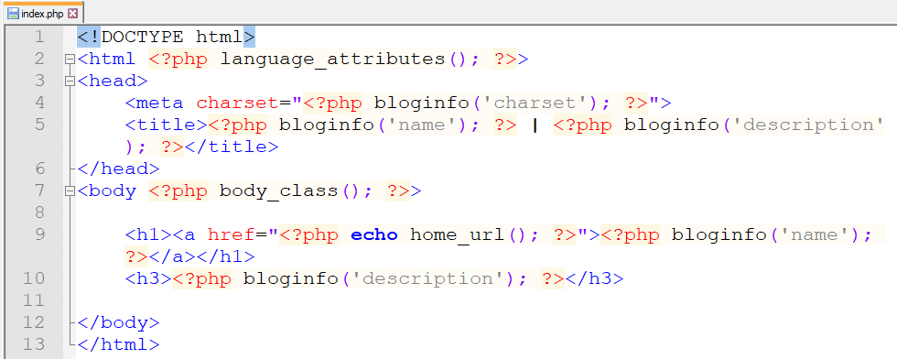
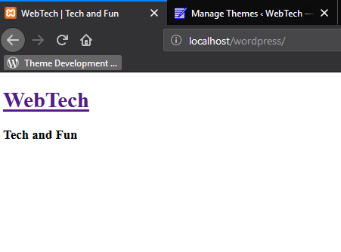
- Now, write a code index.php for publish you dynamic post
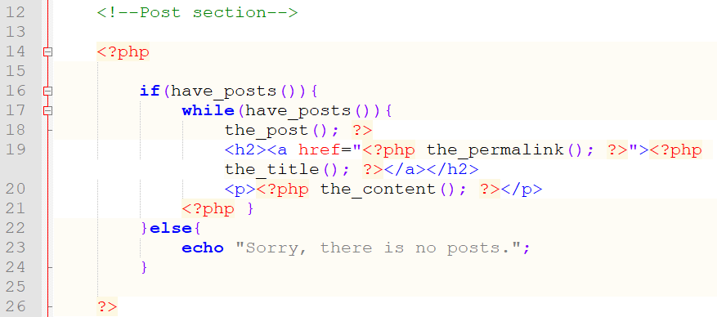
Or
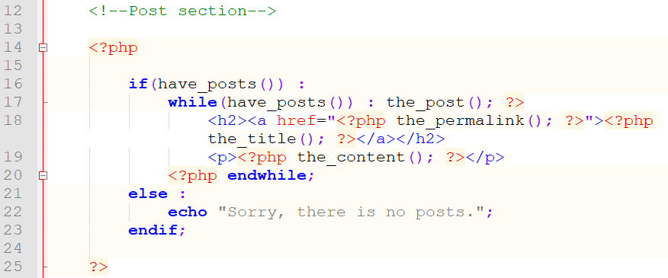
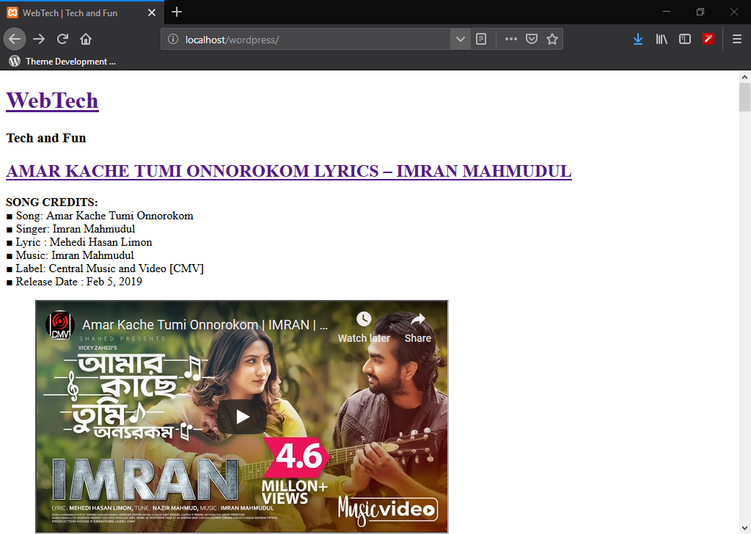

10. img src call a php code <img src="<?php echo get_template_directory_uri(); ?>/img/up.jpg" />

WordPress Theme Customization full part:-

- Include your project file in a theme folder and main stylesheet link with index.php. So, write a code in index.php at head section under title tag.
<link rel="stylesheet" href="<?php bloginfo('stylesheet_url'); ?>" />

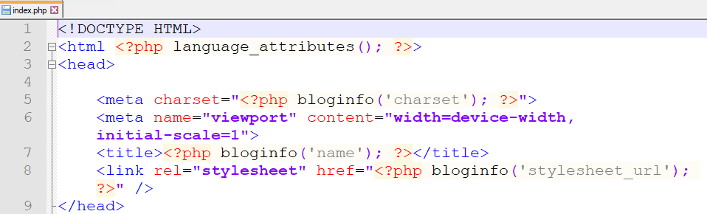
- Create a file functions.php and delete your link tag in head section under title tag.
- Link any stylesheet or script file
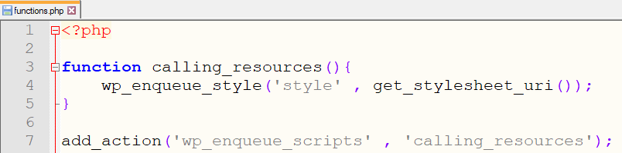
<?php
function calling_resources(){
wp_enqueue_style('style' , get_stylesheet_uri());

wp_enqueue_style('comments_style' , get_template_directory_uri().’/css/something.css’, ’’, ‘1.0.0’);
}
add_action('wp_enqueue_scripts' , 'calling_resources');

index.php file:
end of head tag write a code <?php wp_head(); ?>
end of body tag write a code <?php wp_footer(); ?>

Reference link: wp_enqueue_script

wp_enqueue_style( string $handle, string $src = '', array $deps = array(), string|bool|null $ver = false, string $media = 'all' )

Some example:
/**
* Proper way to enqueue scripts and styles
*/
function wpdocs_theme_name_scripts() {
wp_enqueue_style( 'style-name', get_stylesheet_uri() );
wp_enqueue_script( 'script-name', get_template_directory_uri() . '/js/example.js', array(), '1.0.0', true );
}
add_action( 'wp_enqueue_scripts', 'wpdocs_theme_name_scripts' );

- If you want to control your script version, you write a code in functions.php below:
<?php
function calling_resources(){
wp_enqueue_style('style' , get_stylesheet_uri(), ‘’, ‘1.0.0’);
}
add_action('wp_enqueue_scripts' , 'calling_resources');

- If you want to separate your index.php file in a header.php & footer.php file, you just call two code index.php. In start position in index.php you write <?php get_header(); ?> and end position write <?php get_footer(); ?> .
- Now, you want to custom file added in any page like as index.php, so you write a code <?php get_template_part('mytext'); ?> . ‘mytext’ is a custom file name suppose you create a file mytext.php in root folder.
- Dynamic title in head tag and SEO usable.
<title><?php if (is_single() || is_page()) { wp_title('',true); } elseif(is_front_page()) { bloginfo('description'); } else { bloginfo('description'); } ?> | <?php bloginfo('name');?></title>
- And your website heading, sub heading can set you. As reason you see 2 no page.
- Dynamic menus:
header.php $→$ menu section $→$ write a code:

<?php wp_nav_menu(); ?>

functions.php $→$ register_nav_menus();

- Dynamic and customize menu: header.php (Primary Menu)
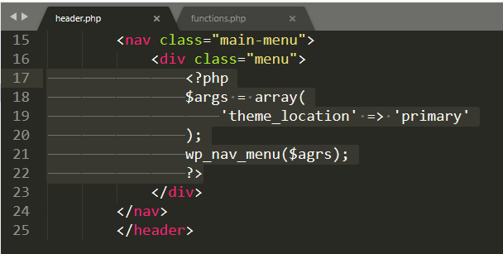

functions.php:
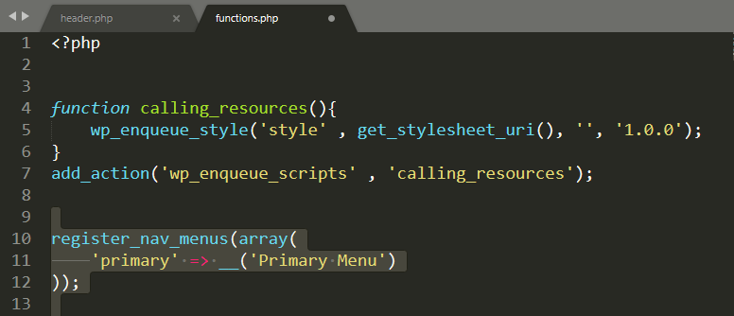

Dynamic menu: footer.php (footer menu)
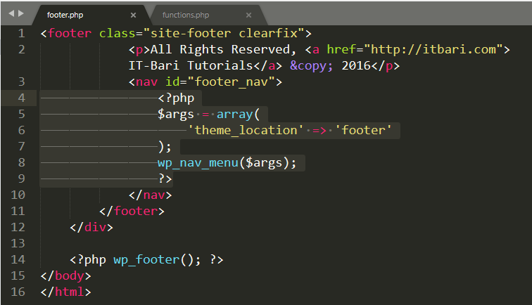
functions.php:
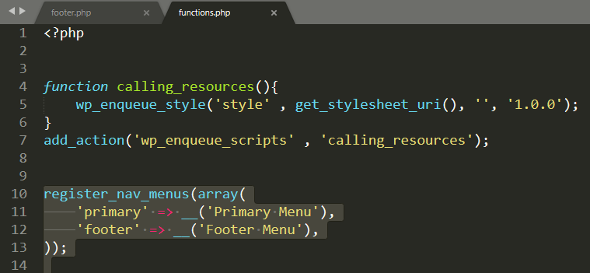
- If you want to publish your dynamic post in your webpage, you can see 3no page.

- Post meta:

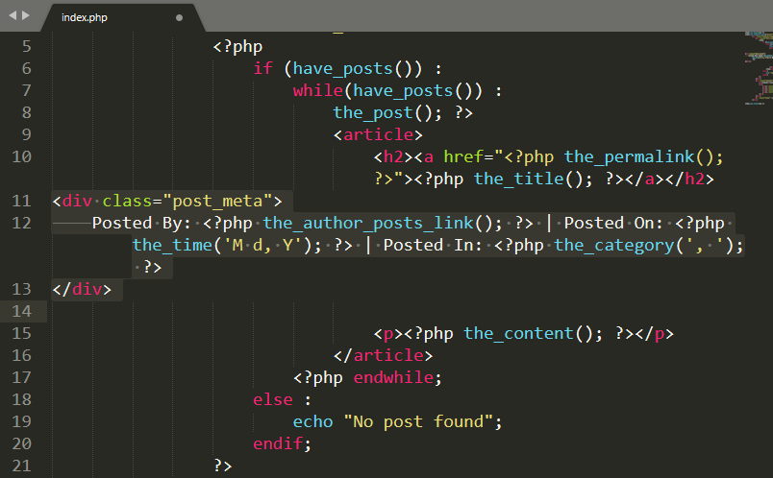

- Featured Image or Post thumbnails:
functions.php register featured image:

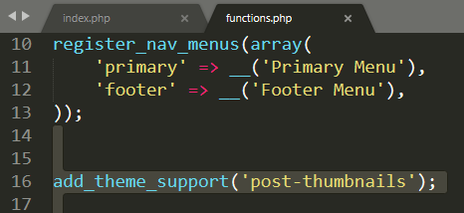

index.php:
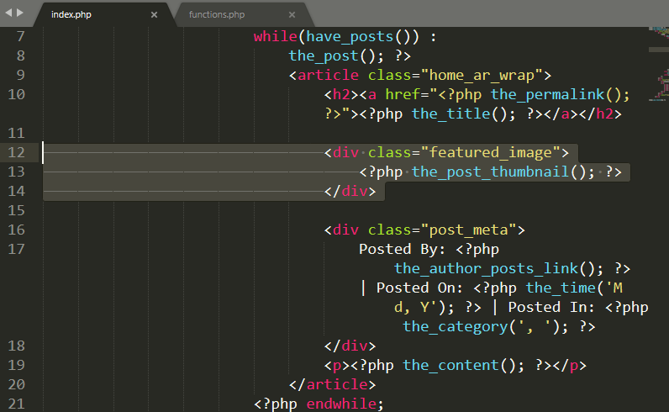
Set your img size in your stylesheet as your wish and link to img use permalink.
<a href="<?php the_permalink(); ?>"><?php the_post_thumbnail(); ?></a>

functions.php :standard method:
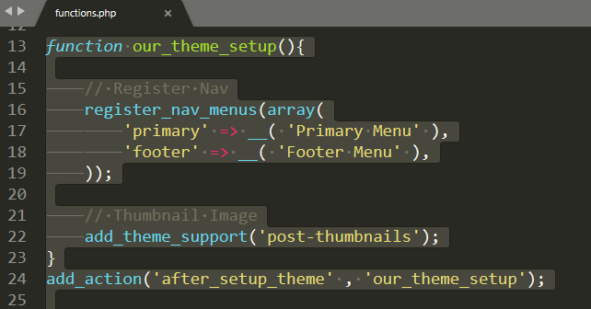

- Sidebar or Widget register.
Cut the part of sidebar to index.php and write a code in index.php <?php get_sidebar(); ?>
Create a new file sidebar.php and paste the code that you were cutting.
Dynamic sidebar or widget:
sidebar.php:

<?php dynamic_sidebar('sidebar'); ?>

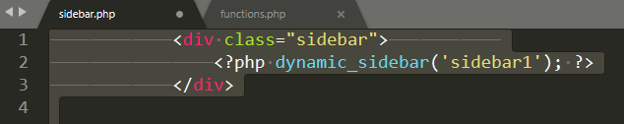
functions.php
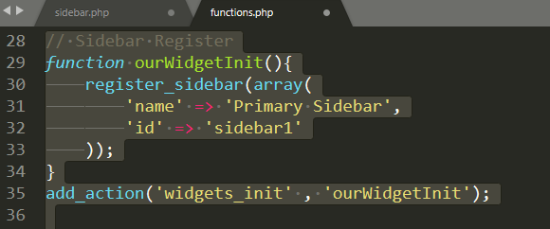
Or

//sidebar
function ourWidgetInit(){
register_sidebar(array(
'name' => 'Primary Sidebar',
'id' => 'sidebar1',
'before_widget' => '<aside id="main_sidebar">',
'after_widget' => '</aside>',
'before_title' => '<h2>',
'after_title' => '</h2>',
));
}

add_action('widgets_init', 'ourWidgetInit');
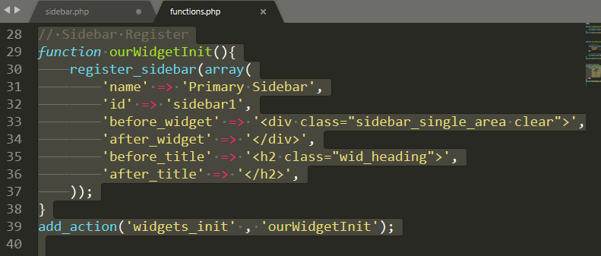

If you create multiple widget, Follow again upper picture. Just separate your widget part in a another page like as multiple_widget.php and this page call index.php widget location as your wish use a code <?php get_template_part(‘multiple_widget’); ?>

- If you control your post in a custom page, you create a file single.php and include elements like index.php elements.
- If you control your page, create a file page.php and copy index.php and paste in page.php.
- If you want to create individual page, you can create this page two way. Use page slug and page id number. Page slug: http://localhost/wordpress/sample-page/
If your page name sample page, your page slug is sample-page.
When you edit sample page, you look URL:
http://localhost/wordpress/wp-admin/post.php?post=2&action=edit
post=2 and your sample page’s id number = 2.
And you can create a page like page-2.php, when you should use page id. But if you can create page use slug, create a page page-sample-page.php
- If you want to create custom page template, just page.php copy and paste and rename this page like fullwidth-template.php
And you follow under the picture write the code like picture.
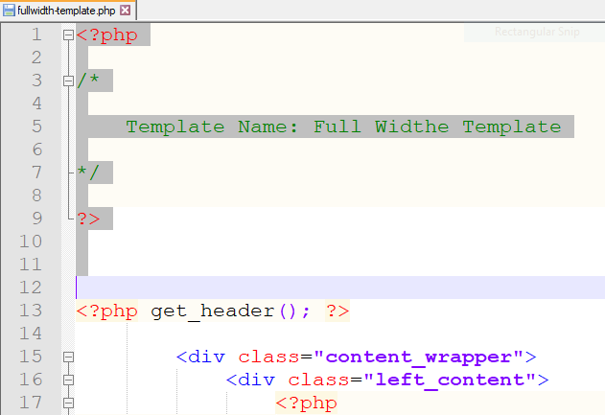
Now, You go edit page and select page attributes and select a template name.
- Excerpt:
functions.php:
Code:
// Excerpt Function
function excerpt($num) {
$limit = $num+1;
$excerpt = explode(' ', get_the_excerpt(), $limit);
array_pop($excerpt);
$excerpt = implode(" ",$excerpt)." <a href='" .get_permalink($post->ID) ." ' class='readmore'>Continue Reading &raquo;</a>";
echo $excerpt;
}
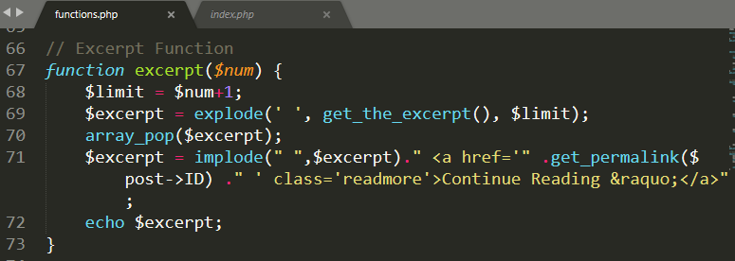
index.php
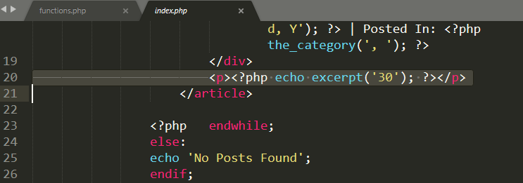
Excerpt(‘write a value’);

20. Archive page: copy a page and rename the page “archive.php”. Write some code for show a archive name.

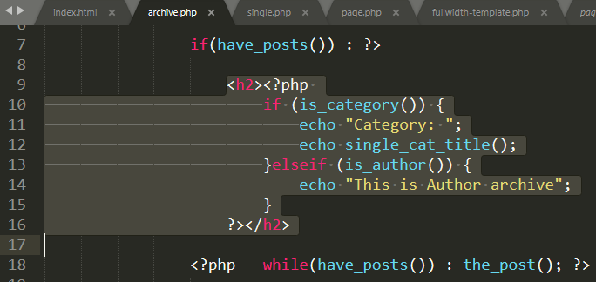

if (is_category()) {
echo "Category: ";
echo single_cat_title();
}elseif (is_author()) {
echo "This is Author archive";
}

Or

<?php $post = $posts[0]; // Hack. Set $post so that the_date() works. ?>

<?php /* If this is a category archive */ if (is_category()) { ?>

<?php _e('Archive For'); ?> '<?php echo single_cat_title(); ?>' <?php _e('Category'); ?>

<?php /* If this is a tag archive */ } elseif( is_tag() ) { ?>

<?php _e('Archive For'); ?> <?php single_tag_title(); ?> <?php _e('Tag'); ?>

<?php /* If this is a daily archive */ } elseif (is_day()) { ?>

<?php _e(' Archive For '); ?> <?php the_time('F jS, Y'); ?>

<?php /* If this is a monthly archive */ } elseif (is_month()) { ?>

<?php _e('Archive For'); ?> <?php the_time('F, Y'); ?>

<?php /* If this is a yearly archive */ } elseif (is_year()) { ?>

<?php _e('Archive For'); ?> <?php the_time('Y'); ?>

<?php /* If this is a search */ } elseif (is_search()) { ?>

<?php _e('Search Results'); ?>

<?php /* If this is an author archive */ } elseif (is_author()) { ?>

<?php _e('Author Archive For'); ?> '<?php echo get_the_author(); ?>'
<?php /* If this is a paged archive */ } elseif (isset($_GET['paged']) && !empty($_GET['paged'])) { ?>

<?php _e('Blog Archives'); ?>

<?php } ?>

- Comments: <?php comments_popup_link( $zero, $one, $more, $css_class, $none ); ?>

<?php comments_popup_link( ‘No Comment’, ‘1 Comment’, ‘% Comments’, ‘my_comment_class’, ‘Comment Off’ ); ?>
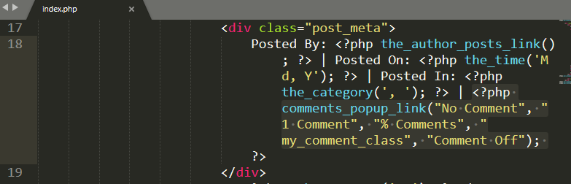

If you want to style comments template, you download a css file from internet and link this stylesheet on functions.php

21. pagination:

<?php next_posts_link("Older Posts &raquo;"); ?>
<?php previous_posts_link("&laquo; Newer Posts"); ?>

custom pagination:
include some code in functions.php for custom pagination.
functions.php code:
/* Custom Pagination */
function pagination($pages = '', $range = 4){
$showitems = ($range * 2)+1;
global $paged;
if(empty($paged)) $paged = 1;
if($pages == ''){
global $wp_query;
$pages = $wp_query->max_num_pages;
if(!$pages){$pages = 1;}
}
if(1 != $pages){
echo "<div class=\"pagination\"><span>Page No- ".$paged." of ".$pages."</span>";

if($paged > 2 && $paged > $range+1 && $showitems < $pages)
echo "<a href='".get_pagenum_link(1)."'>&laquo; First</a>";

if($paged > 1 && $showitems < $pages) echo "<a href='".get_pagenum_link($paged - 1)."'>&lsaquo; Previous</a>";

for ($i=1; $i <= $pages; $i++){
if (1 != $pages &&( !($i >= $paged+$range+1 || $i <= $paged-$range-1) || $pages <= $showitems )){
echo ($paged == $i)? "<span class=\"current\">".$i."</span>":"<a href='".get_pagenum_link($i)."' class=\"inactive\">".$i."</a>";
}
}
if ($paged < $pages && $showitems < $pages)
echo "<a href=\"".get_pagenum_link($paged + 1)."\">Next Page &rsaquo;</a>"; if ($paged < $pages-1 && $paged+$range-1 < $pages && $showitems < $pages) echo "<a href='".get_pagenum_link($pages)."'>Last Page &raquo;</a>";
echo "</div>\n";
}}

include some code in index.php for custom pagination.
index.php code:
<?php if (function_exists("pagination")) { pagination($additional_loop->max_num_pages);} ?>

include some style in style.css for custom pagination style.
style.css code:
.pagination {
clear: both;
padding: 5px 0;
position: relative;
font-size: 96%;
line-height: 13px;
margin: 0.5em 0;
overflow: hidden;
}
.pagination span{padding:0 13px;}
.pagination span, .pagination a {
display:block;
float:left;
margin: 2px 2px 2px 0;
padding:11px;
text-decoration:none;
width:auto;
color:#fff;
background: #555;
}

.pagination a:hover{
color:#fff;
background: #6B710E;
}

.pagination .current{
padding:11px;
background: #6B710E;
color:#fff;
}

22. custom searh form:
<?php get_search_form(); ?>

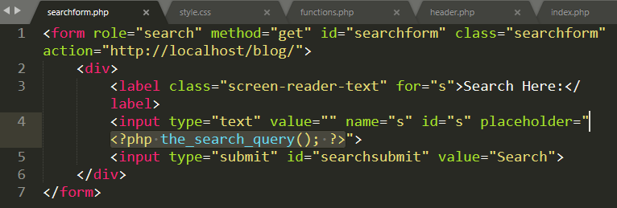

23. If you want to custom search page, you copy and paste index.php file in a search.php file.
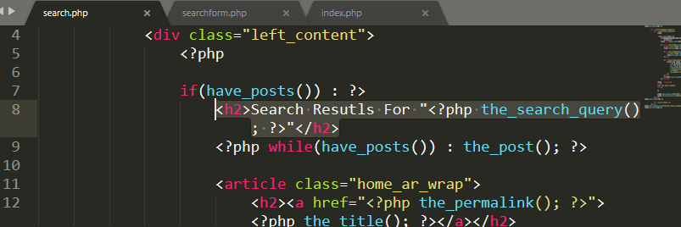
<h2>Search Resutls For "<?php the_search_query(); ?>"</h2>

24. If you want to separate all same code in a file just like content.php, you copy and paste this code and follow the 6 no part in this document.
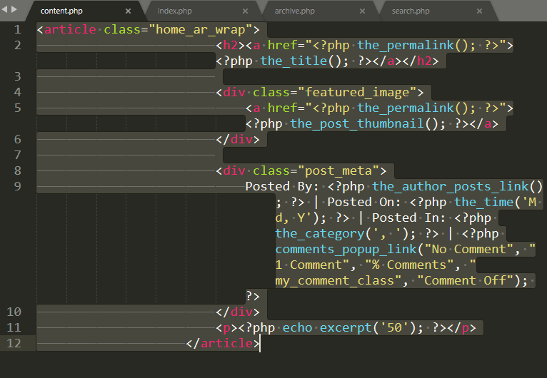

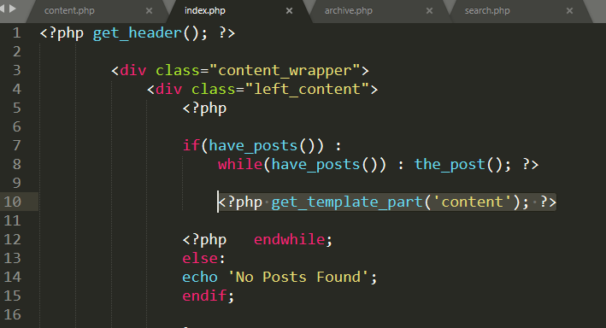

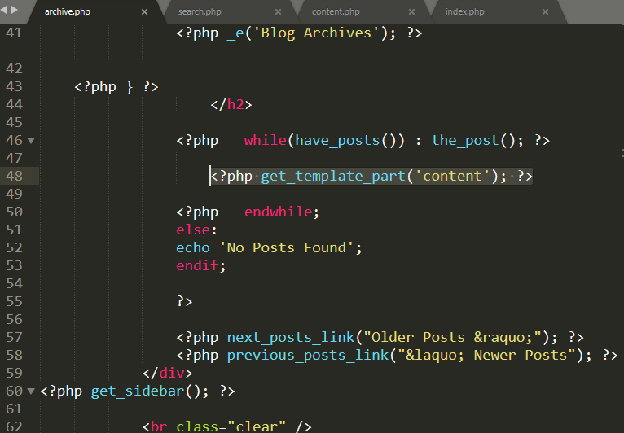

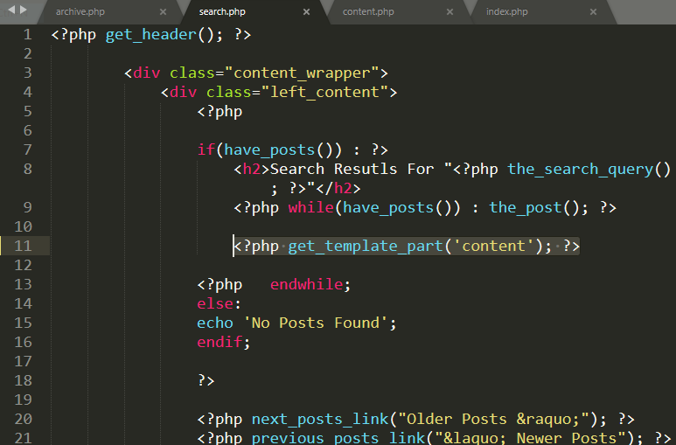

25. If you want to active menu in your navbar, you use devtools in your browser and use a class in stylesheet and you also see youtube video. Just like bellow.
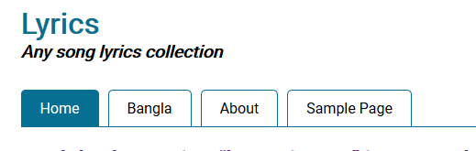



26. 404 page: You create a 404.php file in root folder.
27. Theme Screenshot: take a screenshot you wordpress site and save the image with screenshot.png or screenshot.jpg any format in your root folder and resize it by 1200px $×$ 900px and go to theme.

28. slider:
include some code in funcstion.php for custom slider.

register_post_type('customslider', array(
'labels' => array(
'name' => 'Slider',
'add_new_item' => 'Add new slider'
),
'public' => true,
'supports' => array(
'title', 'thumbnail'
)
));
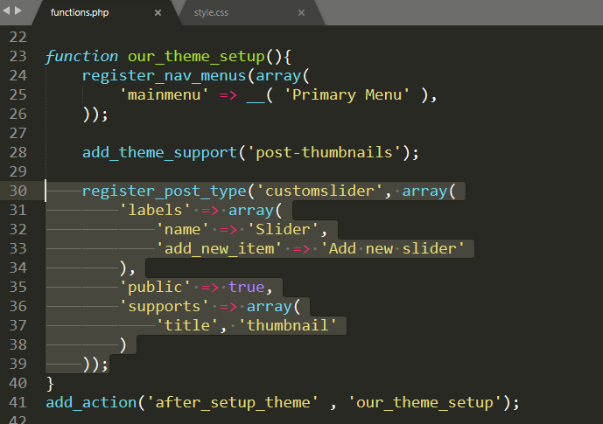

and include another code in slider.php:
<?php
$custom_slider = new WP_Query(
array(
'post_type' => 'customslider',
)
);
while ($custom_slider->have_posts()) : $custom_slider->the_post();?>
<?php the_post_thumbnail(); ?>
<?php endwhile;
?>
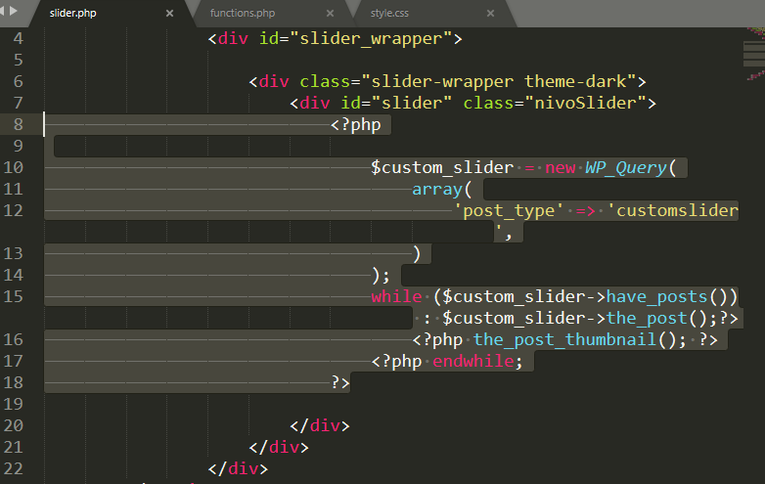
and go to dashboard and look at left site include a new option ‘slider’. Add some slider and visit your website.

